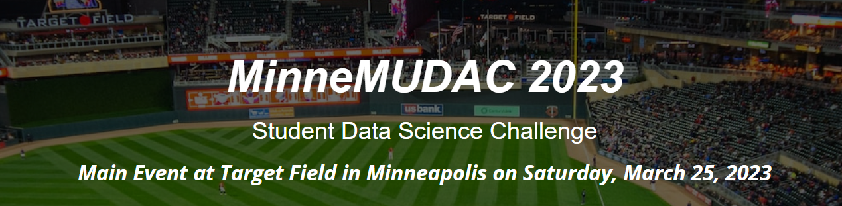

This document contains information regarding the submission of your predictions for the MinneMUDAC 2023 Student Data Science Challenge.

**Prediction Requirements**

Novice Division: Predictions are *only* required for the bonus component of the Novice division. Novice division teams who wish to be considered for the Bonus Award are asked to make predictions for all MN Twins home games for the 2023 season.

Undergraduate / Graduate Divisions: Making predictions for all home games for all MLB teams for the 2023 season is a requirement for the undergraduate and graduate divisions.

**Predictions Files**

Novice Division: Filename: 2023_MLBSchedule_Novice.csv.

This file includes one row for each home game for the MN Twins for the entire 2023 season. There are 81 rows in this file.

Undergraduate / Graduate Division: Filename: 2023_MLBSchedule.csv.

This file includes one row for each home game for all MLB teams for the entire 2023 season. There are 2430 (30 teams * 81 home games) rows in this file.

Comment: As previously mentioned – MLB baseball has a small number of games being played at atypical locations (Estadio Alfredo Harp Helu, London Stadium, and Muncy Bank Ballpark). Predictions for the home-game attendance of these games (GameID_406, GameID_428, GameID_1155, GameID_1172, and GameID_1869) are not needed as these games will be excluded from consideration in the quality of prediction metrics.

**Prediction File Structure**

The prediction file that is submitted must include the columns provided in the above files AND

1. A column that includes your MinneMUDAC TeamID. Your MinneMUDAC TeamID will be provided in an email a few days before the event date.
2. A column that includes the predicted attendance for each home game.

**Submitting Your Predictions**

* The link to access the submission form will be provided to you in an email a few days before the event date.
* Your predictions must be submitted before the start of judging on the day of the event.
* A *.csv file type is required for the submission.
* Save/print a copy of your submission receipt. You may be asked to provide this receipt in the event that something is wrong with your submission.
* You can submit repeatedly. Only the most recent prediction file that was submitted is kept.
* After making a submission, you can confirm your submission by downloading a copy of the file submitted.
* A video describing the process for making submission for the MinneMUDAC 2023 Data Competition is provided here.

Submitting Your Predictions Video: [**https://youtu.be/vYUWhiIL33o**](https://nam02.safelinks.protection.outlook.com/?url=https%3A%2F%2Fyoutu.be%2FvYUWhiIL33o&data=05%7C01%7Ccmalone%40winona.edu%7C603c232bc1804d2c944008db2a6407ad%7C5011c7c60ab446ab9ef4fae74a921a7f%7C0%7C0%7C638150381871192489%7CUnknown%7CTWFpbGZsb3d8eyJWIjoiMC4wLjAwMDAiLCJQIjoiV2luMzIiLCJBTiI6Ik1haWwiLCJXVCI6Mn0%3D%7C3000%7C%7C%7C&sdata=GZYEsy4wEc7ntS0Qjxj75tFOiWRtlyIewAr5MMWzfZc%3D&reserved=0)